The Proposal - AUSTRALIA, a Wiki-esque website by D3.Team

The idea behind this topic is to provide a highly engaging website about Australia. The team has found some remarkably interesting facts about Australia to share with the world. The theme is essentially divided into two parts, Australia as a place and Australia for its people.

As a place, the team will showcase maps on Australia. We will explore and use geojson files available on Australia. We intent to extrapolate this with interesting information that is not normally known about Australia. Some of the sample maps we will showcase are as follows :

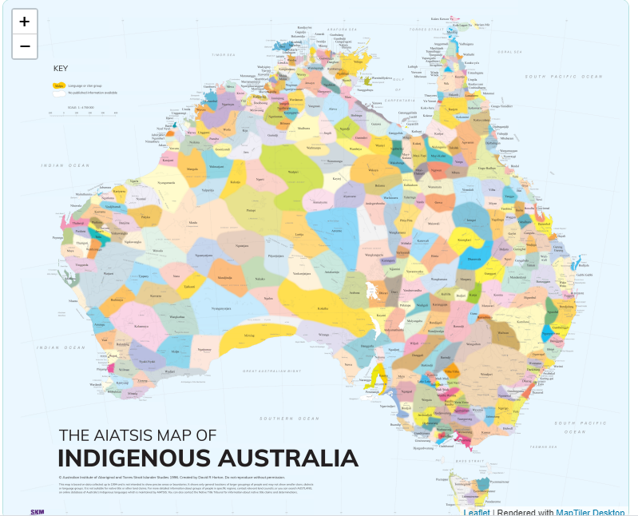

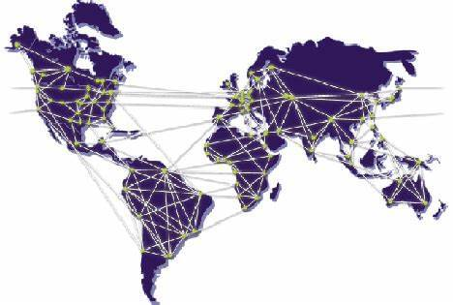

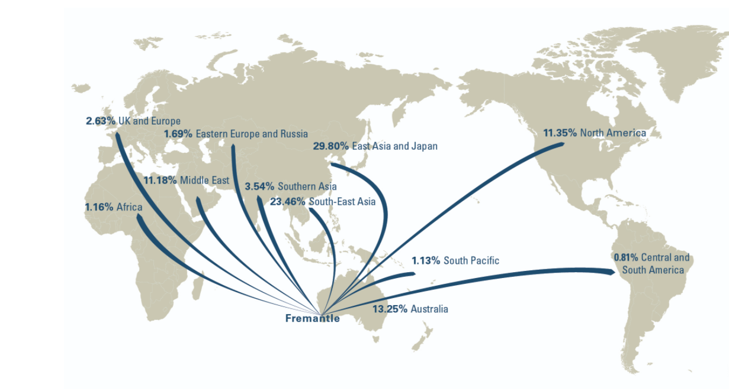

We also intend to highlight interesting locations based on : <https://wikitravel.org/en/Big_things_in_Australia>

On the people of Australia, we intend to web-scrape relevant information from Wikipedia pages such as : <https://en.wikipedia.org/wiki/Demography_of_Australia>

Based on this, we will develop preliminary charts to showcase the people of Australia. Where we believe we could share more in-depth information about the people of Australia, we will deep-dive into this area. This could potentially be further information from official sites such as the Australian Bureau of Statistics.

We intend to chart our graphs using Plotly. We will showcase our graphs similar to the examples below :

